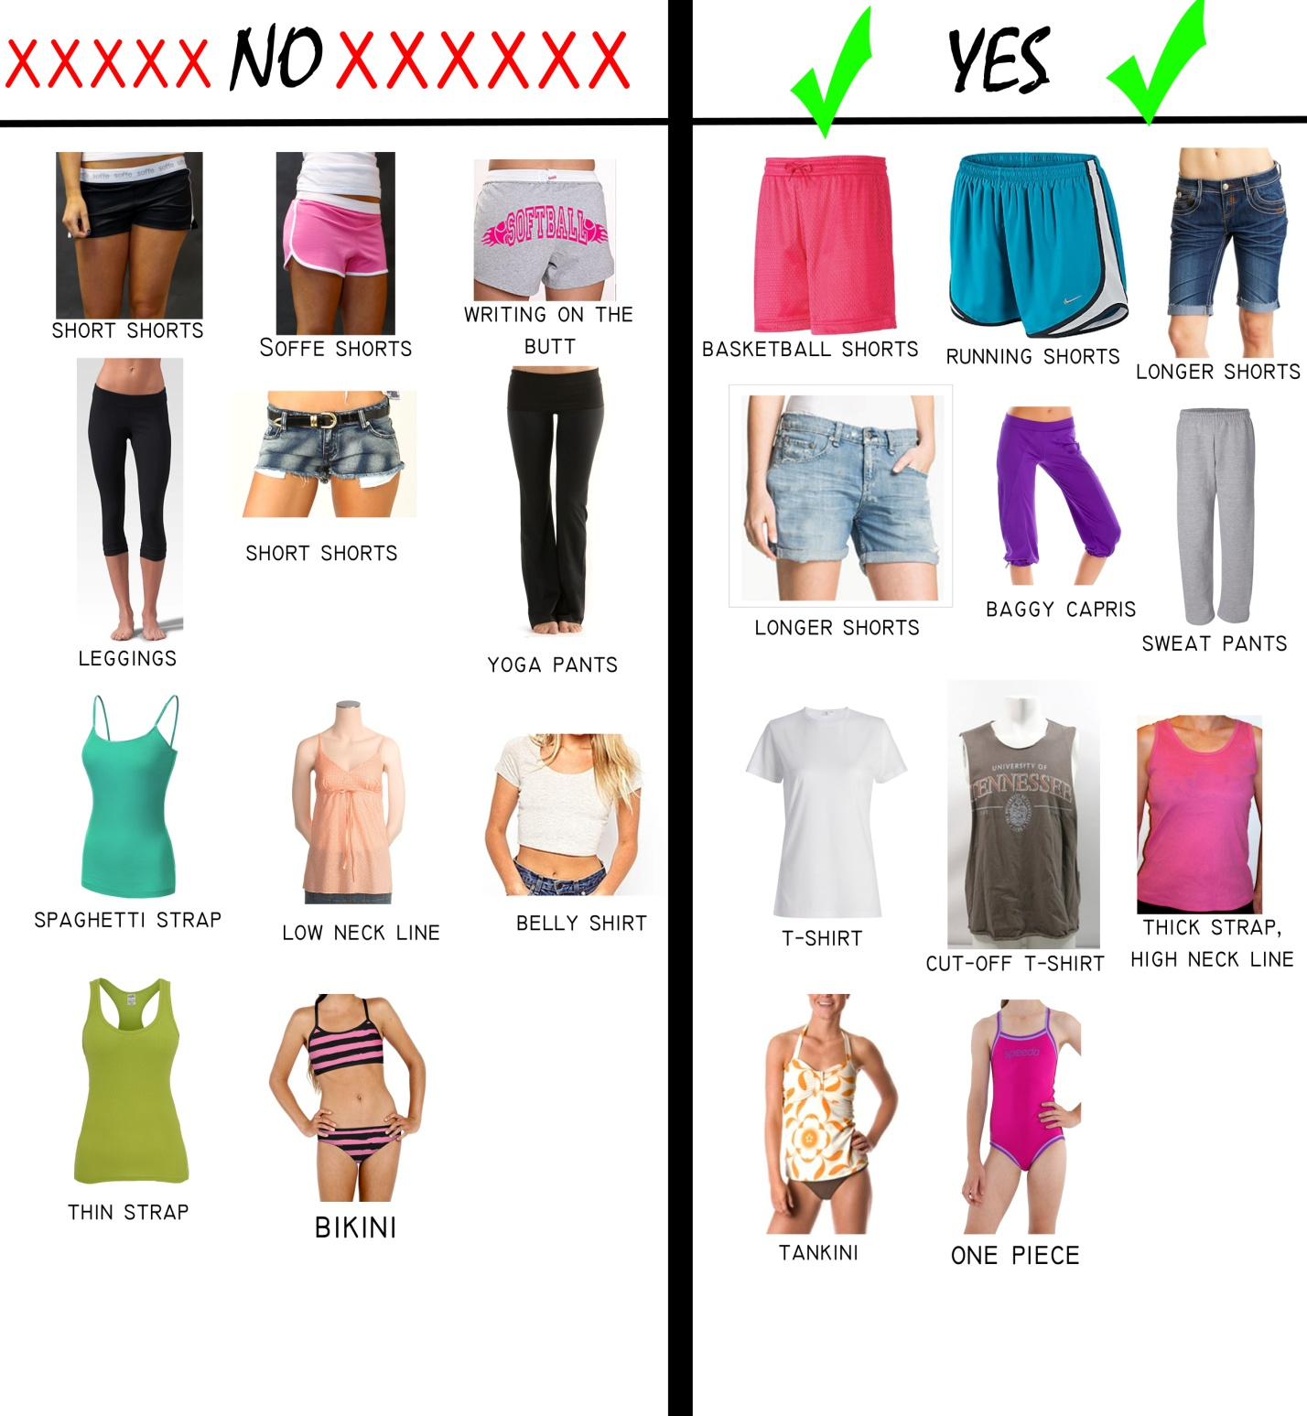
Dress Code Examples

-Parents and ladies: Please make sure you/or your child packs appropriate clothing. The clothing depicted above on the left is not appropriate for Junior High Camp, the clothing on the right is. Our goal in having the dress code is to be modest and display Christ while we focus on Him not on looking appealing to the opposite gender.

-If girls fail to comply with this dress code, more modest clothing will be provided and must be worn. We expect high school and college serving ones to set the standard in complying with this dress code.

-Side note: Make sure a pair of athletic shoes is packed; everyone will be participating in all activities, whether outdoors or indoors.

Sincere Thanks,
The JHC Planning Team

